What is a GPU? (Deep, Practical & Real-World Explanation)
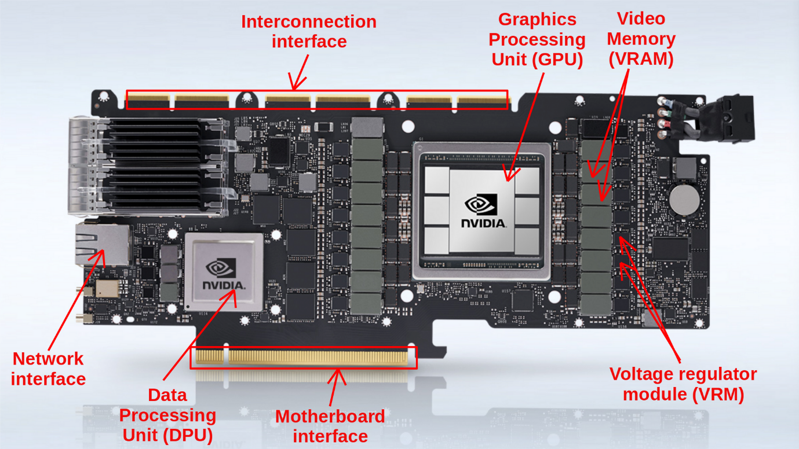
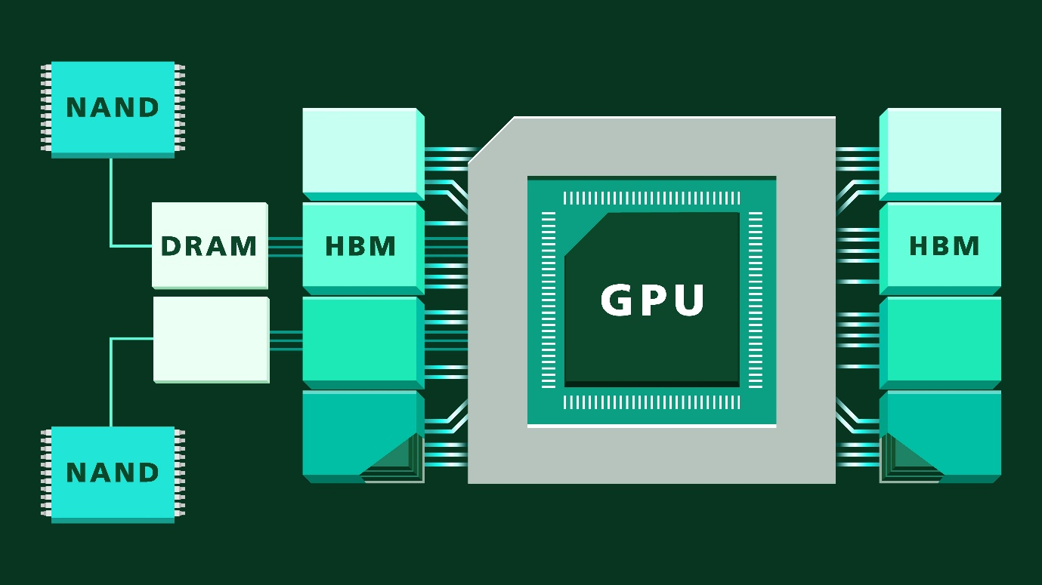
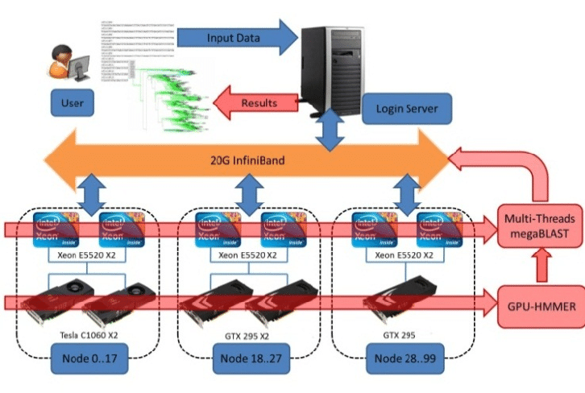
🎨 GPU = Graphics Processing Unit
A GPU is a specialized processor designed to handle:
- Graphics (images, video, 3D)
- Massive parallel computation
⚡ Thousands of small cores
- A GPU has hundreds to thousands of tiny cores
- Each core is simple, but they work together
CPU vs GPU (Core Idea)
CPU | GPU
Manager | Factory
Few powerful cores | Thousands of small cores
Handles decisions & logic | Handles bulk work
Serial processing | Parallel processing
📌 Simple analogy
- CPU = Project manager (decides what to do)
- GPU = Assembly line (does a lot of work at once)

🔁 Why GPUs Are So Powerful

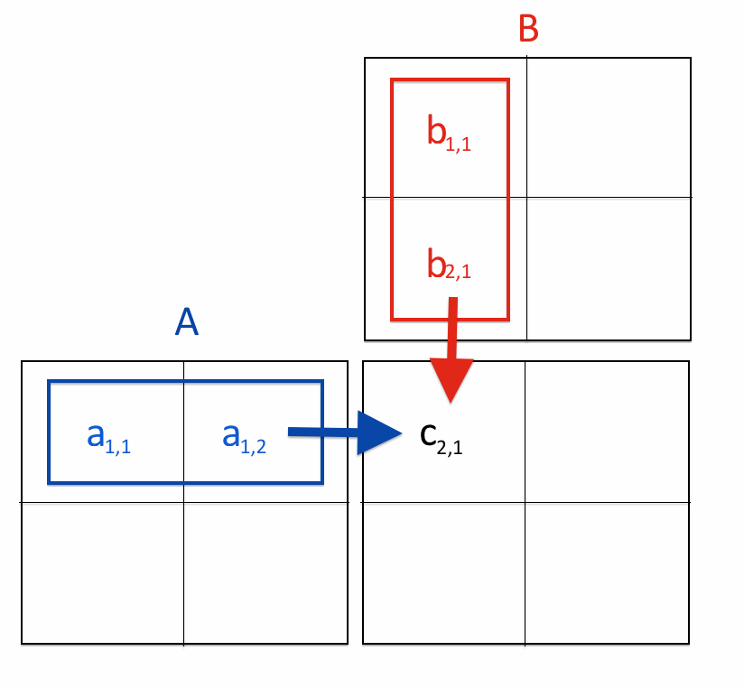
GPUs excel at:
- Doing the same operation on huge data
- Vector & matrix math
- Image and signal processing
That’s why GPUs dominate:
- Gaming graphics
- AI / ML
- Video encoding
- Scientific simulations

🎯 When Do You Need a GPU?
✅ GPU is NEEDED for
🎮 Gaming
- Renders frames
- Handles textures, lighting, shadows
- Higher GPU → higher FPS & quality
🧠 AI / ML
- Matrix multiplication
- Neural network training
- CUDA / ROCm acceleration
🎥 Video Editing
- Timeline playback
- Encoding / decoding
- Effects & color grading
🧱 3D Rendering
- CAD
- Blender
- Simulation meshes

❌ GPU is NOT Needed for
- Office work (Word, Excel)
- Browsing
- Programming (basic)
- Online classes
👉 Integrated GPU is enough here.

🧩 GPU Types (Very Important)
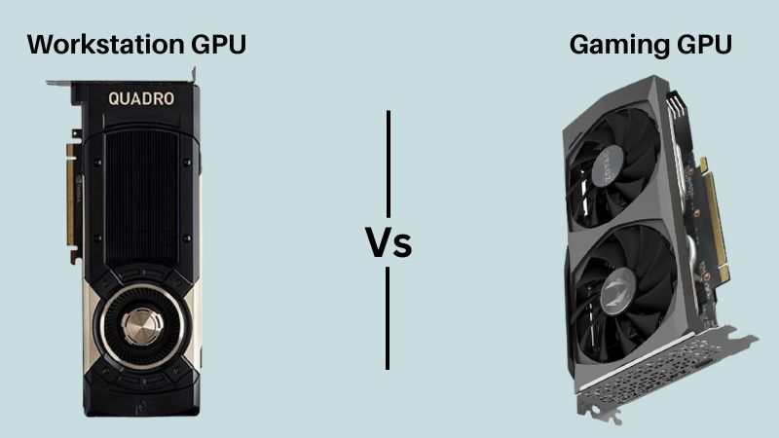
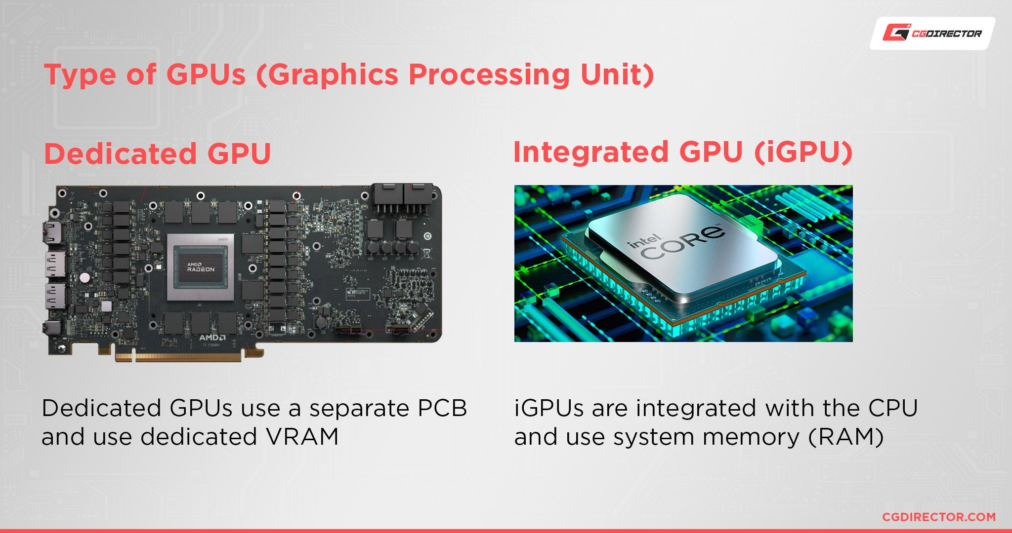
1️⃣ Gaming GPUs
Examples:
- NVIDIA GeForce
- AMD Radeon RX
Optimized for:
- High FPS
- Real-time rendering
- Gaming workloads

2️⃣ Workstation GPUs
Examples:
- NVIDIA RTX A-series
- AMD Radeon Pro
Optimized for:
- Accuracy
- Stability
- Certified drivers
- CAD, medical, scientific workloads
⚠️ More expensive, not for gaming value.

3️⃣ Integrated GPUs (iGPU)
Examples:
- Intel Iris Xe
- AMD Radeon (APUs)
- Built into CPU
- Uses system RAM
- Low power, low performance
Good for:
- Office
- Browsing
- Light coding
- Casual graphics

🧠 Same Idea, Different Optimization
All GPUs:
- Do parallel work
- Use VRAM
- Use shaders / compute units
Difference is software tuning, not basic concept.

🔍 GPU Specs That REALLY Matter

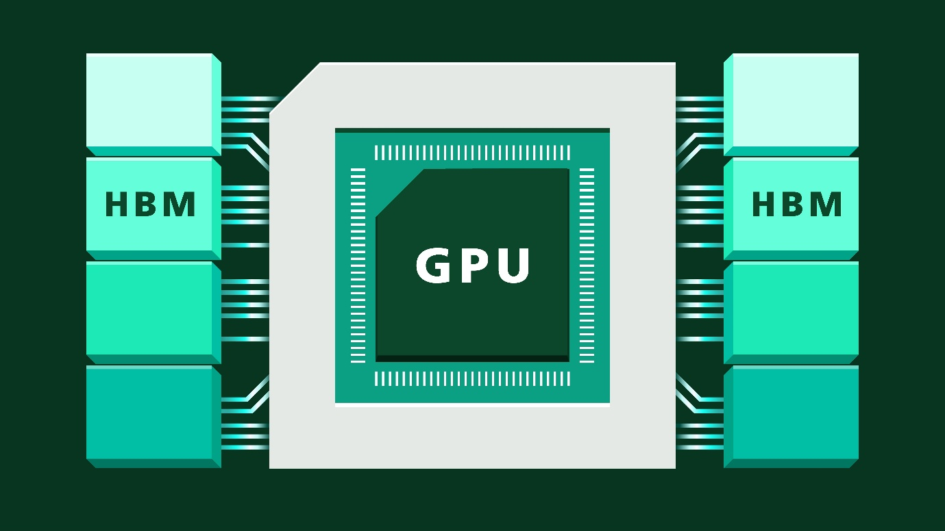
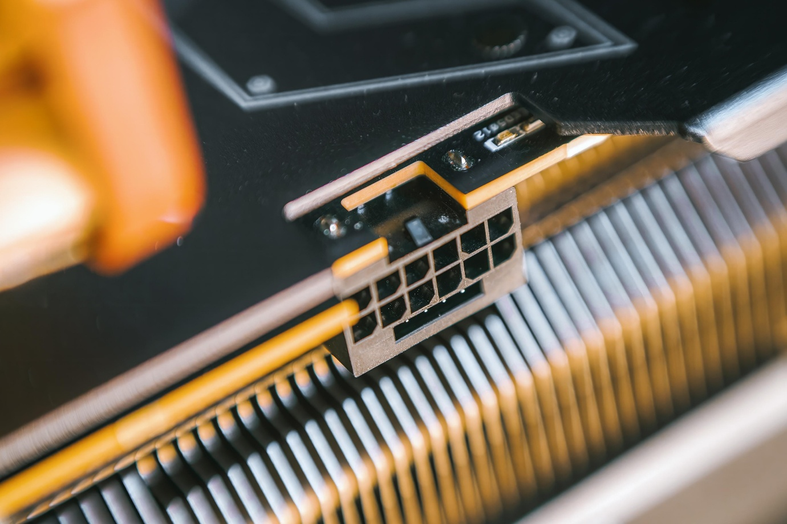
1️⃣ 💾 VRAM (Video Memory)
- Stores textures
- Stores models
- Stores AI tensors
Task | VRAM Needed
Office | 0–1 GB
Gaming (1080p) | 6–8 GB
AI / ML | 12–24+ GB
3D / Video | 8–16 GB
📌 More VRAM = handle larger data
📌 VRAM does NOT increase raw speed alone

2️⃣ ⚡ Core Count (CUDA / Stream Processors)
- NVIDIA → CUDA cores
- AMD → Stream processors
More cores:
- Better parallel performance
- Faster rendering & compute
⚠️ Core count across brands is not directly comparable

3️⃣ 📊 Memory Bandwidth
- How fast data moves between GPU & VRAM
- Depends on:
  - Memory type (GDDR6, GDDR6X)
  - Bus width (128-bit, 256-bit)
High bandwidth = smoother performance in:
- High resolution gaming
- AI workloads

4️⃣ 🔌 Power Consumption (TDP)
- GPUs consume a lot of power
- Entry GPU → 75–120W
- Mid GPU → 150–250W
- High-end → 300–450W+
📌 More power = more heat = more cooling needed

❌ Marketing Specs ≠ Real Performance
Misleading specs:
- Boost clock alone
- VRAM size alone
- “AI cores” count alone
Real performance depends on:
- Architecture
- Memory bandwidth
- Driver optimization
- Cooling

⚡ GPU Power & Size Reality (Critical)
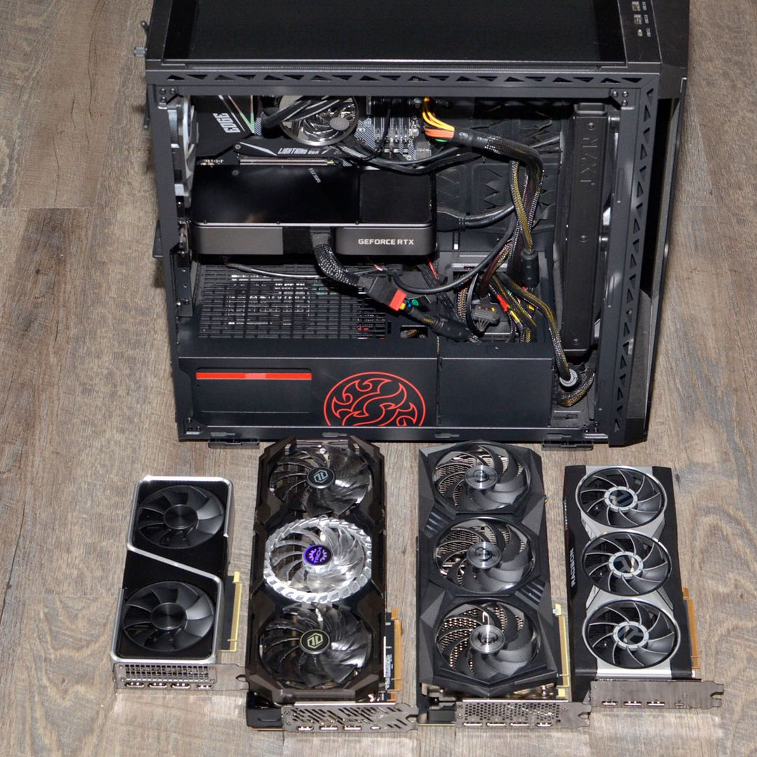
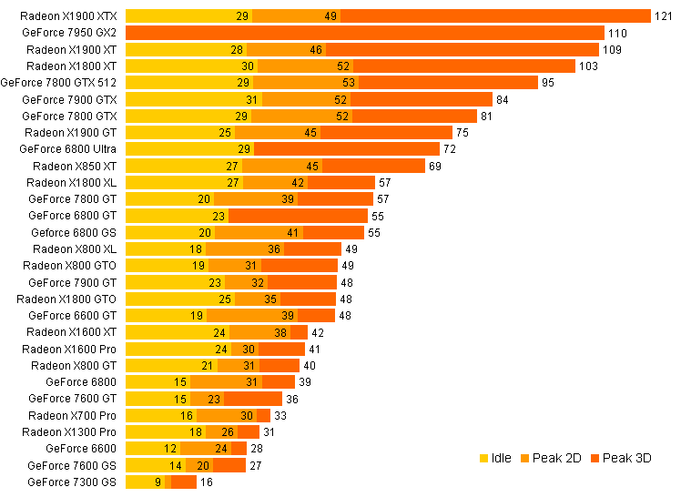
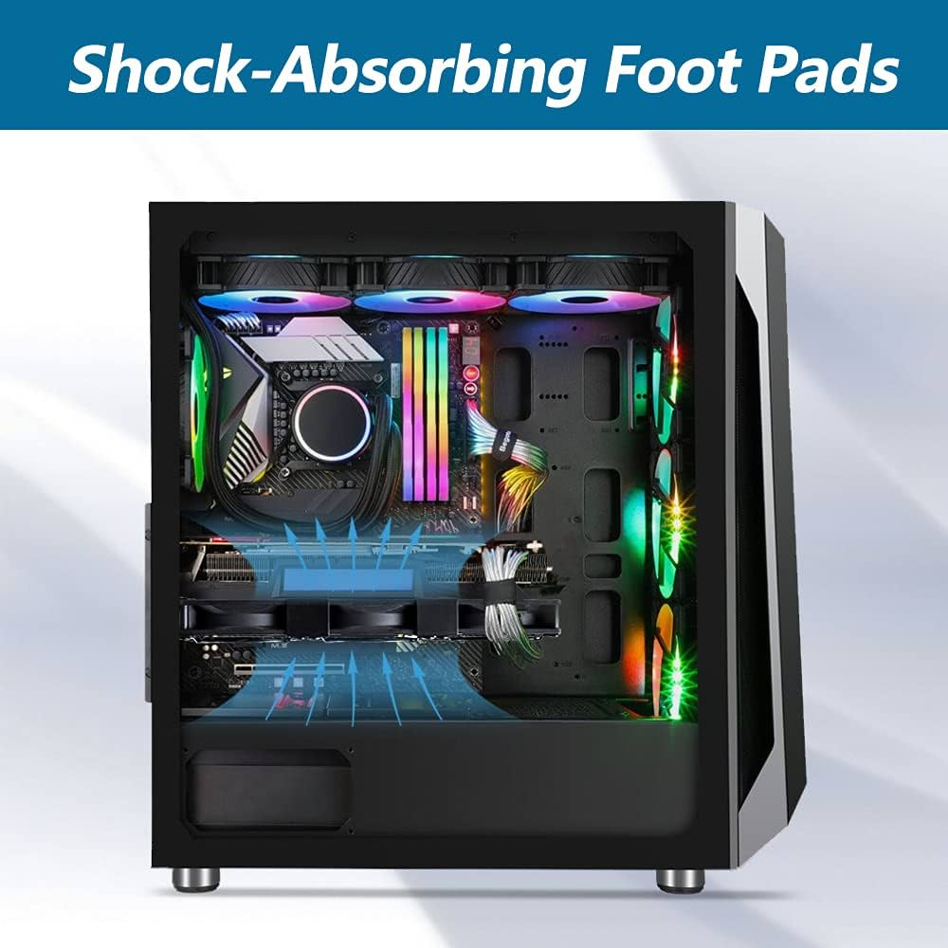
⚡ Power Supply (PSU)
- GPU needs dedicated PCIe power cables
- Weak PSU → crashes or shutdowns
Rule of thumb:
- Mid GPU → 650W PSU
- High GPU → 750–850W PSU

📏 Physical Size
- GPUs are BIG
- Check:
  - Length (mm)
  - Thickness (2-slot, 3-slot)
  - Case clearance

❄️ Cooling & Airflow
- GPUs dump heat into case
- Poor airflow → throttling
- Good case fans are mandatory

🧪 Real Example (Why GPU Choice Matters)
Same CPU, Different GPUs
GPU | Result
Integrated | Can’t run AI
Entry GPU | Basic ML
High-end GPU | Fast training
CPU same
RAM same
GPU changed → huge difference

🧠 GPU + Your Workload (Your Context)
For AI / simulations / MedTech:
- VRAM matters more than FPS
- Stability matters more than RGB
- Cooling matters more than looks
Often:
- AMD → better value
- NVIDIA → better AI ecosystem (CUDA)

🏁 Final Truth
- GPU = parallel work engine
- Needed only for specific workloads
- VRAM enables size, not speed
- Power & size are real constraints
- Your workload decides GPU choice

🧠 One-Line Summary
CPU thinks.
GPU works.
And for AI, graphics, and rendering — GPU decides speed.

